Technical documentation of CSV to excel conversion tool

this is a excel tool where we have created a macro written in VBA (Visual Basic for Application) , which is basically used to automate the most tedious job. so here we have used a macro to convert the csv file to excel file and to do the required formatting.

This tool takes the .csv file as an input file and produce/generate the excel file.

Below is the interface to execute the macro for the respective reports,

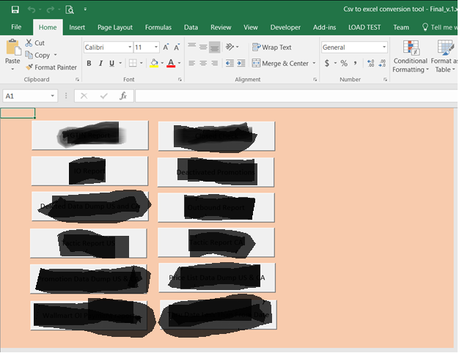

Say to convert a Get_data Record.csv file to a excel file you need to hit the Get_data Report Button on the interface.

So when you hit on the Get_data Report button it will search for the folder named “Input” in the same location where this tool is saved and in this Input folder it will search for the GTIN Record.CSV file. In case if it is not able to file the Input folder it will throw an exception as below,

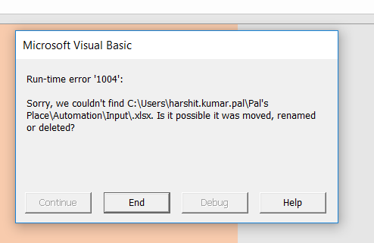

And you need to terminate this program.

So, in this case just check the folder, if not create the folder and put the Get_data Record.csv file in it.

In case if it not able to find a Get_data Record.csv file in the input folder, then it will throw a run time error as below,



Once the right file is in right place it will open it convert it in to excel save in it the same location where this tool is saved in the output folder.

Steps it performs during the conversion,

1. It will initiate a workbook creation,

//Workbooks.Add

1. add a worksheet to the new created workbook,
2. select the range contains the data in the csv file

//ActiveSheet.Select

//Cells.Select

1. copy the selection,

// Selection.Copy

1. activate the new created workbook

// Workbooks.Add

//Set wb = ActiveWorkbook

//wb.Activate

1. paste the copied part in the active workbook
2. make the top row bold, and freeze it
3. save the excel file.